**Project 5 – Wisdom of Crowds**

Zachary Shumate

[CECS]

Speed School of Engineering

University of Louisville, USA

znshum01@louisville.edu

1. **Introduction** (What did you do in this project and why?)

This project involved solving the Traveling Salesman Problem using a Wisdom of Crowds enhanced genetic algorithm. This is the same genetic algorithm I used in the previous project which accepts a list of cities and then generates a population of solutions for many generations in order to generate increasingly optimal routes. Once the genetic algorithm has finished running through a predetermined number of generations, I took some of the best solutions and used a form of wisdom of crowds in an attempt to gain even better results.

1. **Approach** (Describe algorithm you are using for this project)

The genetic algorithm for this script runs exactly the same as the previous project’s using Pyevolve, an imported library, to accept the cities and generate all of the generations of solutions. The Wisdom of Crowds step involved taking the top 25% of solutions, in this case 20, and created a matrix to hold the occurrences of edges between two cities. After this matrix is generated, I created a route using the edges that were most prominent.

1. **Results** (How well did the algorithm perform?)
   1. **Data** (Describe the data you used.)

I used the lists of cities that were provided as well as a list with 100 cities and one with 322 cities. The list of 322 was the largest set tested. Each city had unique coordinates.

* 1. **Results** (Numerical results and any figures or tables.)

**11**:

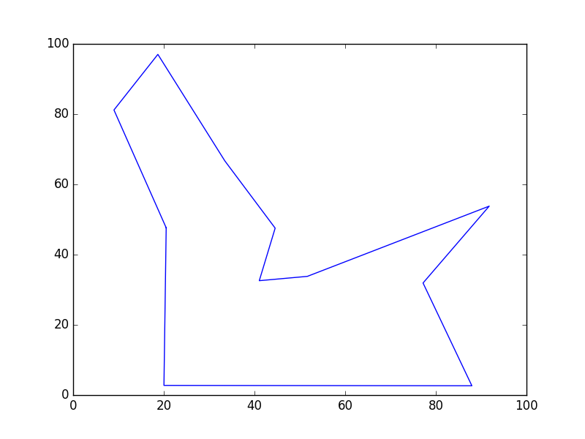

**Score: 351.045880**

**List**: [3, 4, 8, 1, 10, 7, 9, 2, 6, 0, 5]

Total time elapsed: **49.136** seconds.

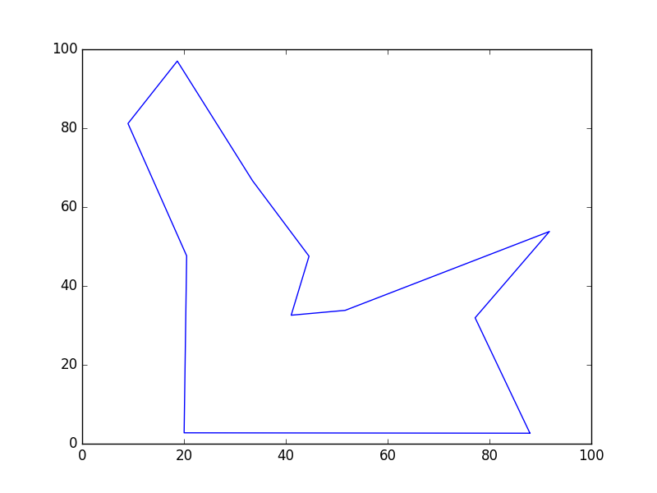

**WofC Score: 351.045879942**

[0, 5, 3, 4, 8, 1, 10, 7, 9, 2, 6]

This script took **49.5628631115** seconds.

**22:**

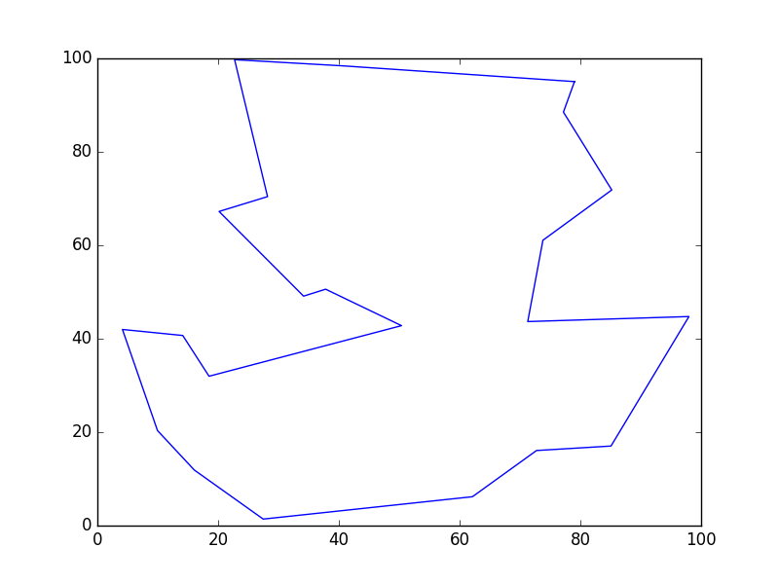

**Score: 416.094642**

**List**: [20, 10, 15, 2, 14, 6, 0, 4, 17, 21, 19, 1, 13, 8, 3, 18, 12, 9, 5, 11, 7, 16]

Total time elapsed: **70.226** seconds.

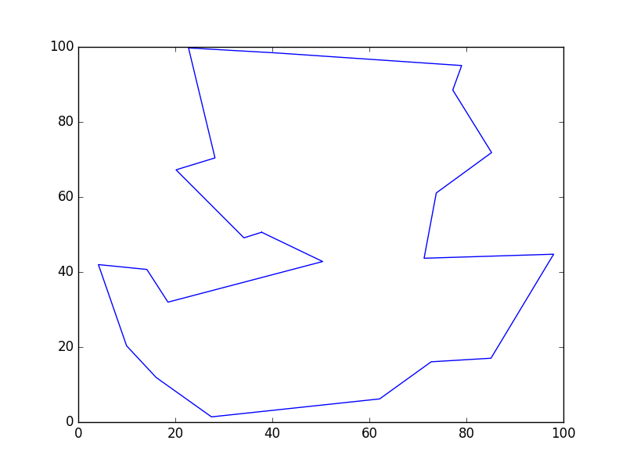

**WofC Score: 416.094641866**

[0, 4, 17, 21, 19, 1, 13, 8, 3, 18, 12, 9, 5, 11, 7, 16, 20, 10, 15, 2, 14, 6]

This script took **70.6359159946** seconds.

**44:**

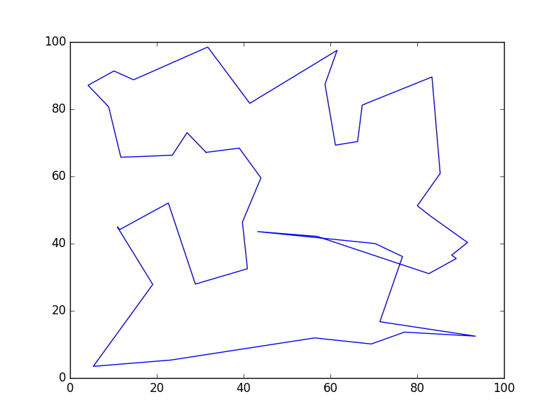

**Score: 613.980665**

**List**: [42, 16, 43, 28, 8, 24, 10, 23, 33, 31, 11, 18, 12, 0, 21, 27, 29, 19, 7, 5, 32, 4, 3, 2, 36, 35, 40, 41, 38, 37, 39, 9, 34, 26, 6, 22, 25, 30, 1, 17, 20, 13, 15, 14]

Total time elapsed: 110.411 seconds.

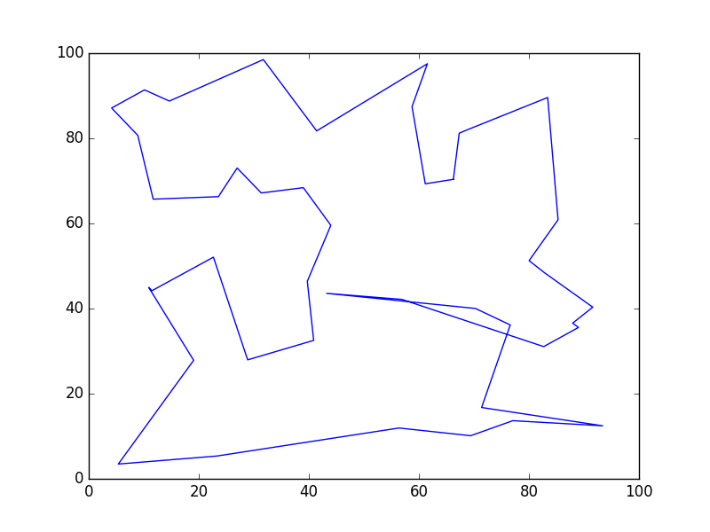

**WofC Score: 613.980664687**

[0, 21, 27, 29, 19, 7, 5, 32, 4, 3, 2, 36, 35, 40, 41, 38, 37, 39, 9, 34, 26, 6, 22, 25, 30, 1, 17, 20, 13, 15, 14, 42, 16, 43, 28, 8, 24, 10, 23, 33, 31, 11, 18, 12]

This script took **110.853014946** seconds.

**77:**

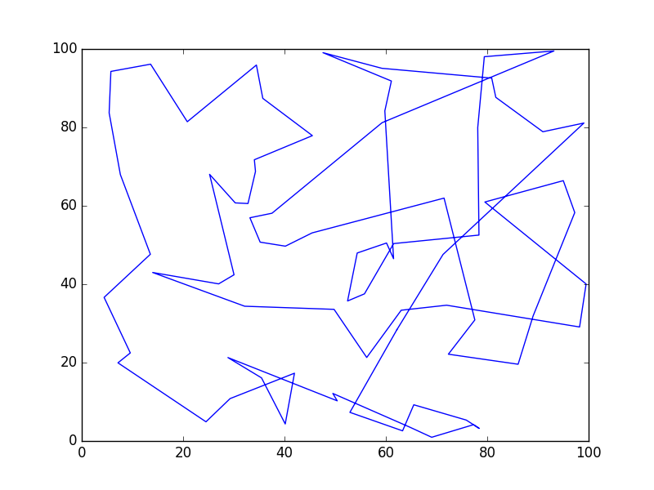

**Score: 1105.365167**

**List**: [5, 66, 13, 32, 67, 73, 72, 39, 54, 22, 15, 45, 21, 65, 33, 70, 55, 51, 61, 62, 18, 34, 56, 23, 49, 37, 8, 11, 7, 76, 69, 47, 46, 27, 43, 24, 31, 16, 58, 12, 30, 29, 19, 52, 75, 9, 63, 50, 36, 57, 10, 42, 0, 4, 2, 64, 38, 26, 6, 44, 59, 20, 41, 35, 3, 48, 40, 25, 71, 74, 17, 14, 68, 53, 60, 28, 1]

Total time elapsed: **147.246** seconds.

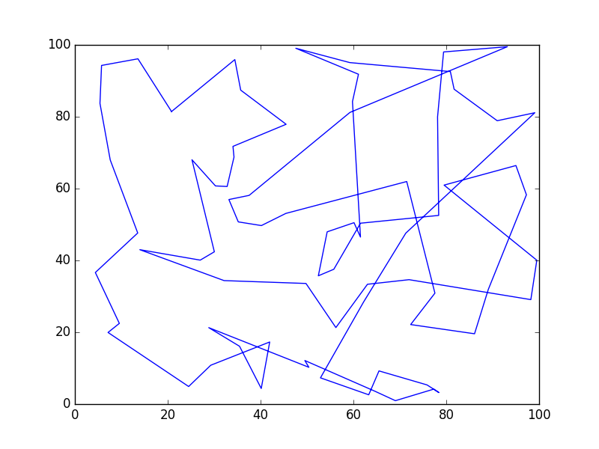

**WofC Score: 1105.36516737**

[0, 4, 2, 64, 38, 26, 6, 44, 59, 20, 41, 35, 3, 48, 40, 25, 71, 74, 17, 14, 68, 53, 60, 28, 1, 5, 66, 13, 32, 67, 73, 72, 39, 54, 22, 15, 45, 21, 65, 33, 70, 55, 51, 61, 62, 18, 34, 56, 23, 49, 37, 8, 11, 7, 76, 69, 47, 46, 27, 43, 24, 31, 16, 58, 12, 30, 29, 19, 52, 75, 9, 63, 50, 36, 57, 10, 42]

This script took **147.678277969** seconds.

**97:**

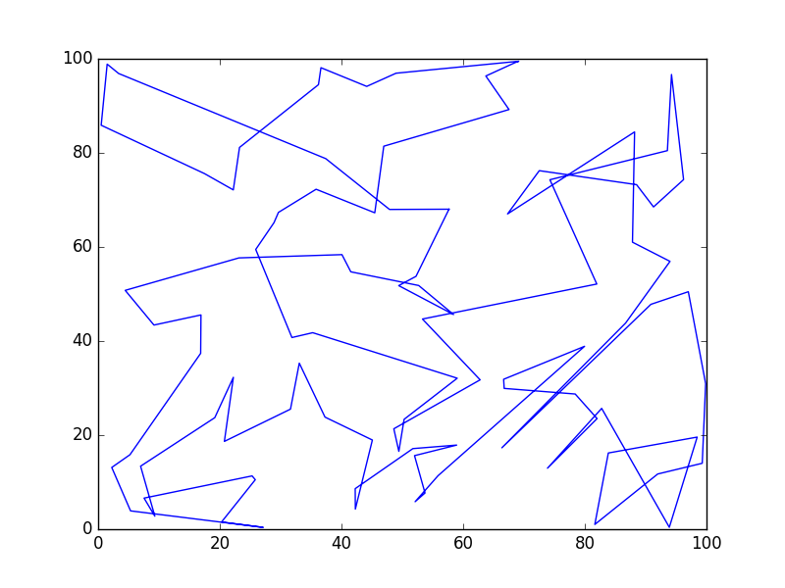

**Score: 1271.322158**

**List**: [47, 19, 58, 85, 91, 86, 67, 42, 7, 10, 65, 57, 55, 39, 49, 37, 92, 70, 50, 48, 14, 35, 4, 31, 88, 64, 90, 30, 56, 75, 24, 18, 59, 52, 81, 84, 95, 93, 80, 61, 78, 3, 33, 23, 44, 45, 20, 74, 82, 69, 77, 73, 5, 21, 71, 13, 1, 9, 46, 26, 41, 38, 34, 54, 6, 27, 28, 32, 53, 17, 72, 11, 8, 16, 94, 43, 40, 25, 68, 76, 29, 12, 2, 36, 83, 87, 62, 0, 89, 15, 66, 96, 22, 79, 60, 63, 51]

Total time elapsed: **194.119** seconds.

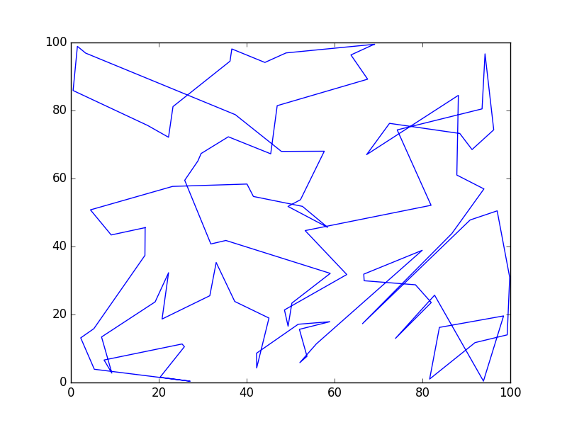

**WofC Score: 1271.32215801**

[0, 89, 15, 66, 96, 22, 79, 60, 63, 51, 47, 19, 58, 85, 91, 86, 67, 42, 7, 10, 65, 57, 55, 39, 49, 37, 92, 70, 50, 48, 14, 35, 4, 31, 88, 64, 90, 30, 56, 75, 24, 18, 59, 52, 81, 84, 95, 93, 80, 61, 78, 3, 33, 23, 44, 45, 20, 74, 82, 69, 77, 73, 5, 21, 71, 13, 1, 9, 46, 26, 41, 38, 34, 54, 6, 27, 28, 32, 53, 17, 72, 11, 8, 16, 94, 43, 40, 25, 68, 76, 29, 12, 2, 36, 83, 87, 62]

This script took **194.571418047** seconds.

**100:**

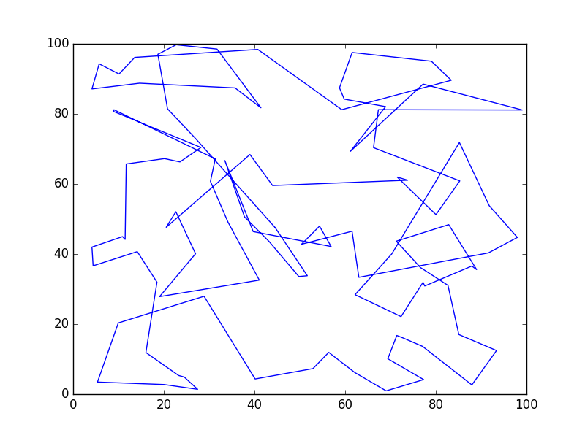

**Score: 1280.233030**

**List**: [10, 9, 89, 68, 11, 1, 46, 69, 98, 15, 92, 93, 65, 20, 2, 18, 73, 82, 84, 6, 88, 37, 36, 38, 16, 74, 35, 23, 70, 0, 72, 29, 71, 42, 91, 94, 14, 67, 78, 80, 50, 12, 39, 5, 19, 97, 59, 24, 28, 32, 83, 30, 58, 63, 61, 25, 76, 13, 41, 4, 75, 86, 17, 7, 53, 55, 96, 34, 3, 47, 48, 22, 85, 40, 52, 33, 54, 90, 27, 45, 60, 99, 51, 44, 31, 62, 95, 21, 81, 43, 79, 57, 56, 87, 64, 66, 26, 8, 77, 49]

Total time elapsed: **189.647** seconds.

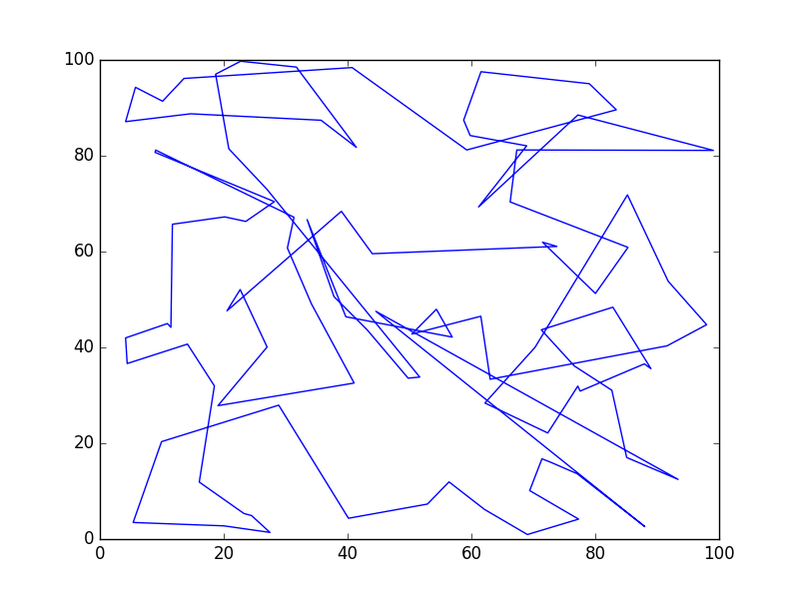

**WofC Score: 1391.49146994**

[0, 72, 29, 71, 42, 91, 94, 14, 67, 78, 80, 50, 12, 39, 5, 19, 97, 59, 24, 28, 32, 83, 30, 58, 63, 61, 25, 76, 13, 41, 4, 75, 86, 17, 7, 53, 55, 96, 34, 3, 47, 48, 22, 85, 40, 52, 33, 54, 90, 27, 45, 60, 99, 51, 44, 31, 62, 95, 21, 81, 43, 79, 57, 56, 87, 64, 66, 26, 8, 77, 49, 9, 89, 68, 11, 1, 46, 69, 98, 15, 92, 93, 65, 20, 2, 18, 73, 82, 84, 6, 88, 37, 36, 38, 16, 74, 35, 23, 70, 10]

This script took **190.110083103** seconds.

**222:**

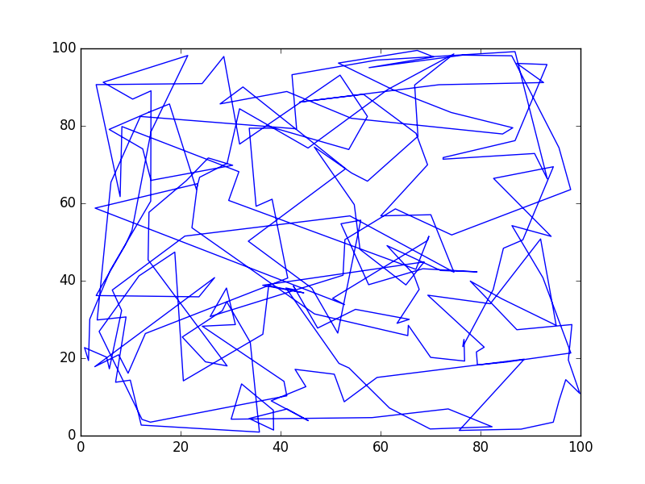

**Score: 3061.678932**

**List**: [218, 60, 100, 68, 163, 49, 75, 71, 136, 185, 90, 188, 196, 140, 143, 191, 103, 192, 63, 169, 97, 104, 85, 142, 3, 180, 176, 82, 148, 79, 170, 149, 6, 175, 56, 178, 116, 168, 150, 190, 51, 89, 42, 12, 73, 151, 2, 55, 32, 114, 39, 1, 117, 5, 160, 197, 105, 164, 189, 47, 199, 210, 171, 107, 52, 202, 125, 93, 69, 64, 95, 121, 174, 201, 110, 129, 109, 179, 145, 177, 8, 211, 44, 162, 138, 204, 80, 22, 198, 132, 172, 184, 119, 159, 11, 61, 106, 147, 27, 87, 115, 24, 43, 113, 101, 137, 4, 67, 84, 146, 155, 131, 221, 10, 152, 173, 154, 219, 9, 214, 86, 120, 112, 99, 53, 96, 215, 0, 102, 35, 34, 38, 126, 167, 135, 17, 37, 14, 165, 18, 31, 7, 187, 50, 15, 70, 83, 217, 33, 207, 28, 157, 36, 94, 72, 45, 59, 128, 16, 58, 23, 213, 124, 29, 21, 40, 158, 123, 127, 78, 195, 206, 74, 141, 122, 77, 62, 57, 108, 183, 92, 156, 30, 139, 88, 205, 25, 161, 193, 212, 203, 26, 98, 65, 76, 134, 209, 182, 111, 153, 181, 66, 200, 19, 186, 54, 208, 216, 41, 166, 46, 220, 48, 144, 133, 13, 118, 91, 130, 20, 81, 194]

Total time elapsed: **384.479** seconds.

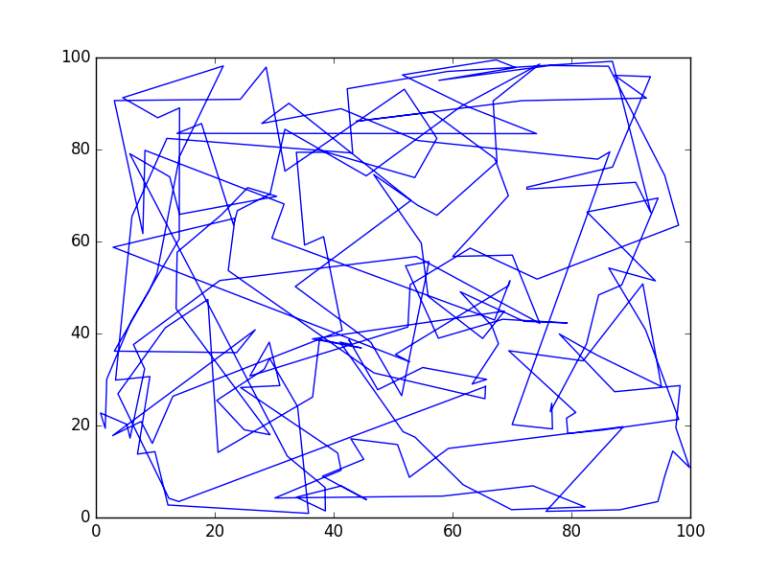

**WofC Score: 3255.70809722**

[0, 102, 35, 34, 38, 126, 167, 135, 17, 37, 14, 165, 18, 31, 7, 187, 50, 15, 70, 83, 217, 33, 207, 28, 157, 36, 94, 72, 45, 59, 128, 16, 58, 23, 213, 124, 29, 21, 40, 158, 123, 127, 78, 195, 206, 74, 141, 122, 77, 62, 57, 108, 183, 92, 156, 30, 139, 88, 205, 25, 161, 193, 212, 203, 26, 98, 65, 76, 134, 209, 182, 111, 153, 181, 66, 200, 19, 186, 54, 208, 216, 41, 166, 46, 220, 48, 144, 133, 13, 118, 91, 130, 20, 81, 194, 44, 162, 138, 204, 80, 22, 198, 132, 172, 184, 119, 159, 11, 61, 106, 147, 27, 87, 115, 24, 43, 113, 101, 137, 4, 67, 84, 146, 155, 131, 221, 10, 152, 173, 154, 219, 9, 214, 86, 120, 112, 99, 53, 96, 215, 32, 114, 39, 1, 117, 5, 160, 197, 105, 164, 189, 47, 199, 210, 171, 107, 52, 202, 125, 93, 69, 64, 95, 121, 174, 201, 110, 129, 109, 179, 145, 177, 8, 211, 148, 79, 170, 149, 6, 175, 56, 178, 116, 168, 150, 190, 51, 89, 42, 12, 73, 151, 2, 55, 218, 60, 100, 68, 163, 49, 75, 71, 136, 185, 90, 188, 196, 140, 143, 191, 103, 192, 63, 169, 97, 104, 85, 142, 3, 180, 176, 82]

This script took **385.047101021** seconds.

**322:**

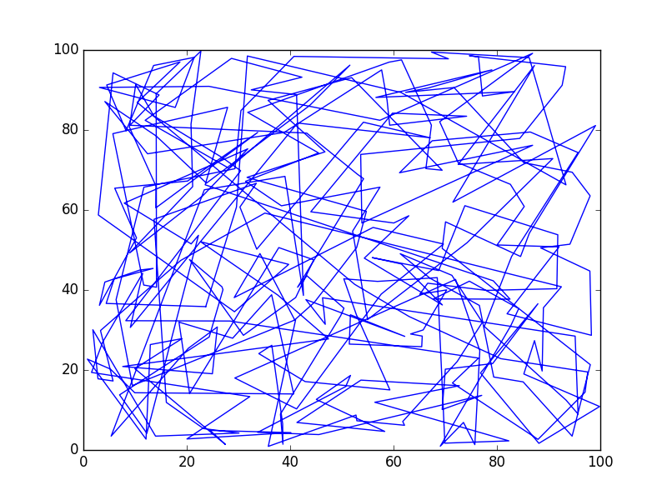

**Score: 5656.290772**

**List**: [123, 265, 66, 171, 234, 151, 173, 112, 21, 170, 263, 61, 157, 159, 7, 316, 219, 78, 14, 209, 84, 6, 16, 152, 114, 74, 321, 23, 247, 252, 117, 256, 220, 254, 90, 85, 312, 165, 176, 268, 164, 147, 288, 194, 75, 175, 149, 282, 44, 54, 33, 239, 317, 87, 240, 118, 243, 278, 269, 53, 17, 106, 289, 137, 299, 248, 244, 207, 153, 161, 277, 94, 35, 237, 192, 225, 212, 271, 76, 217, 294, 103, 32, 227, 26, 77, 218, 224, 200, 183, 191, 107, 208, 134, 276, 286, 270, 96, 158, 3, 249, 301, 10, 11, 185, 28, 50, 163, 179, 154, 222, 241, 308, 145, 55, 12, 19, 97, 80, 5, 144, 174, 280, 63, 119, 64, 188, 139, 297, 86, 1, 113, 24, 59, 311, 182, 306, 116, 177, 300, 242, 136, 273, 36, 111, 213, 110, 215, 206, 196, 37, 231, 315, 42, 72, 122, 304, 284, 210, 232, 108, 180, 229, 29, 67, 91, 245, 279, 310, 69, 15, 267, 259, 272, 141, 204, 262, 238, 298, 89, 235, 68, 172, 296, 260, 253, 4, 56, 79, 226, 266, 46, 34, 197, 195, 228, 148, 275, 320, 39, 138, 47, 221, 101, 105, 211, 115, 281, 13, 251, 125, 168, 121, 57, 181, 128, 142, 51, 95, 155, 99, 48, 130, 216, 98, 246, 92, 291, 292, 22, 2, 65, 201, 302, 203, 73, 169, 193, 100, 202, 264, 9, 82, 274, 135, 205, 104, 127, 70, 88, 38, 290, 132, 190, 45, 126, 283, 307, 214, 293, 303, 236, 189, 27, 62, 305, 31, 285, 102, 261, 18, 314, 250, 319, 186, 20, 143, 184, 167, 40, 52, 109, 198, 60, 309, 133, 150, 287, 160, 140, 81, 131, 258, 8, 223, 156, 93, 255, 124, 187, 0, 71, 199, 146, 162, 230, 49, 318, 43, 41, 120, 178, 257, 25, 166, 129, 313, 30, 58, 233, 295, 83]

Total time elapsed: **585.640** seconds.

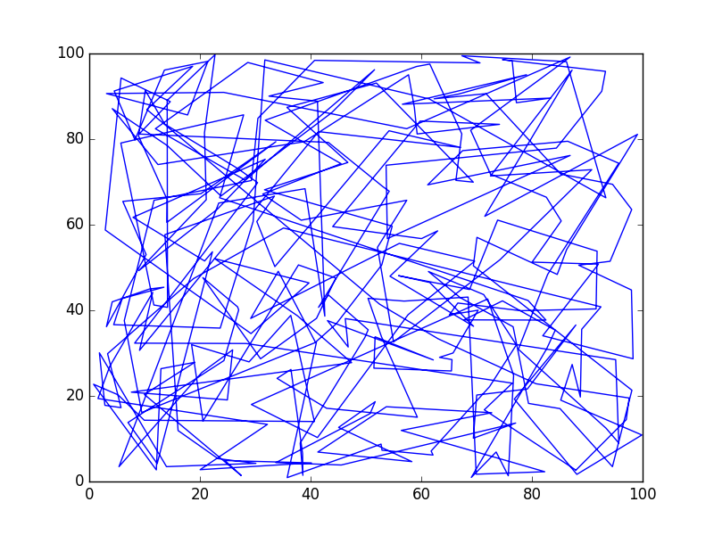

**WofC Score: 5656.29077212**

[0, 71, 199, 146, 162, 230, 49, 318, 43, 41, 120, 178, 257, 25, 166, 129, 313, 30, 58, 233, 295, 83, 123, 265, 66, 171, 234, 151, 173, 112, 21, 170, 263, 61, 157, 159, 7, 316, 219, 78, 14, 209, 84, 6, 16, 152, 114, 74, 321, 23, 247, 252, 117, 256, 220, 254, 90, 85, 312, 165, 176, 268, 164, 147, 288, 194, 75, 175, 149, 282, 44, 54, 33, 239, 317, 87, 240, 118, 243, 278, 269, 53, 17, 106, 289, 137, 299, 248, 244, 207, 153, 161, 277, 94, 35, 237, 192, 225, 212, 271, 76, 217, 294, 103, 32, 227, 26, 77, 218, 224, 200, 183, 191, 107, 208, 134, 276, 286, 270, 96, 158, 3, 249, 301, 10, 11, 185, 28, 50, 163, 179, 154, 222, 241, 308, 145, 55, 12, 19, 97, 80, 5, 144, 174, 280, 63, 119, 64, 188, 139, 297, 86, 1, 113, 24, 59, 311, 182, 306, 116, 177, 300, 242, 136, 273, 36, 111, 213, 110, 215, 206, 196, 37, 231, 315, 42, 72, 122, 304, 284, 210, 232, 108, 180, 229, 29, 67, 91, 245, 279, 310, 69, 15, 267, 259, 272, 141, 204, 262, 238, 298, 89, 235, 68, 172, 296, 260, 253, 4, 56, 79, 226, 266, 46, 34, 197, 195, 228, 148, 275, 320, 39, 138, 47, 221, 101, 105, 211, 115, 281, 13, 251, 125, 168, 121, 57, 181, 128, 142, 51, 95, 155, 99, 48, 130, 216, 98, 246, 92, 291, 292, 22, 2, 65, 201, 302, 203, 73, 169, 193, 100, 202, 264, 9, 82, 274, 135, 205, 104, 127, 70, 88, 38, 290, 132, 190, 45, 126, 283, 307, 214, 293, 303, 236, 189, 27, 62, 305, 31, 285, 102, 261, 18, 314, 250, 319, 186, 20, 143, 184, 167, 40, 52, 109, 198, 60, 309, 133, 150, 287, 160, 140, 81, 131, 258, 8, 223, 156, 93, 255, 124, 187]

This script took **586.209574938** seconds.

1. **Discussion** (Talk about the results you got and answer any specific questions mentioned in the assignment.)

Implementing the Wisdom of Crowds into my genetic algorithm did not seem to have much of an impact on the results, which is why I left out a comparison chart between the base genetic algorithm and the wisdom of crowds enhanced version. This may be due, in part, to the genetic algorithm’s improvement curve flattening out, which leaves little for wisdom of crowds to improve upon; in fact, there were a few occasions where it had a detrimental effect that was most likely due to the genetic algorithm’s mutation or crossover resulting in the best solution thus not informing the wider population. Additionally, processing the wisdom of crowds never took very long; the most time added to this was one second. On another note, the number of cities seemed to have little effect on the wisdom of crowds’ effectiveness; the only possible difference would be that smaller lists that discover the most optimal solution, the Hamiltonian Cycle, with the genetic algorithm’s parameters, the wisdom of crowds cannot possibly get a better solution.

1. **References** (If you used any sources in addition to lectures please include them here.)

I used Pyevolve to help with the genetic algorithm as it has many functions to generate generations and run crossovers as well as mutations. I also used one its example programs from the site as a basis and of my code.

<http://pyevolve.sourceforge.net/0_6rc1/>